
The restored Cruck House at Octon
30th May 2013

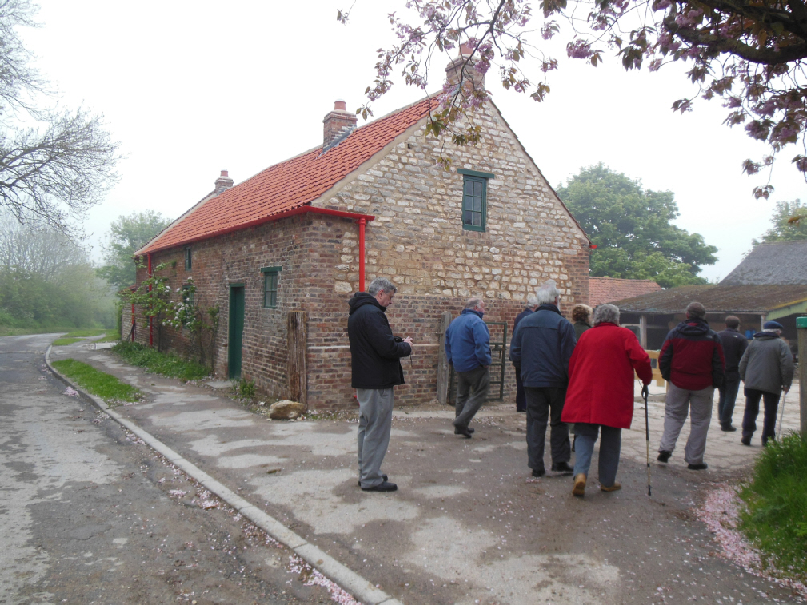

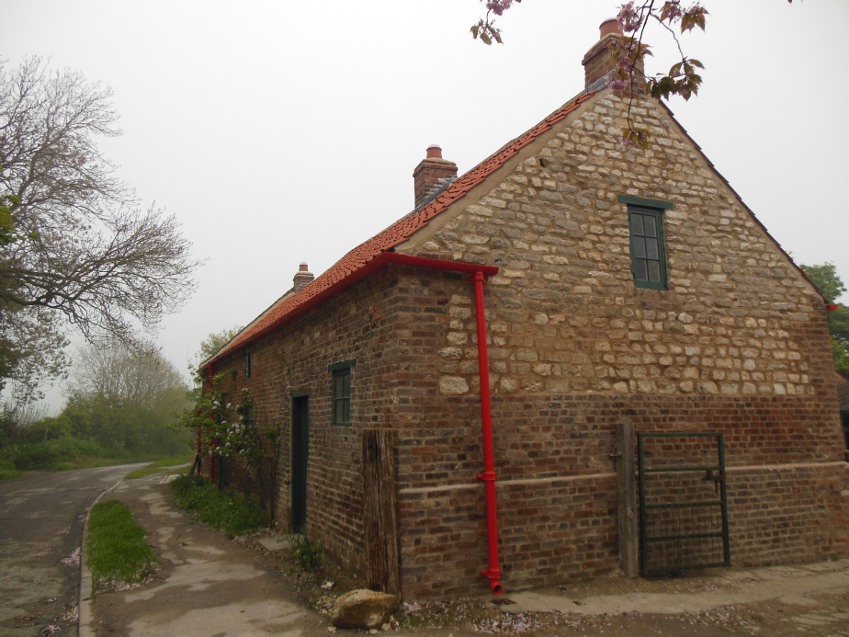

David Bull discussed the restoration of the cruck house. The tiles will soon weather and blend in with the surroundings.

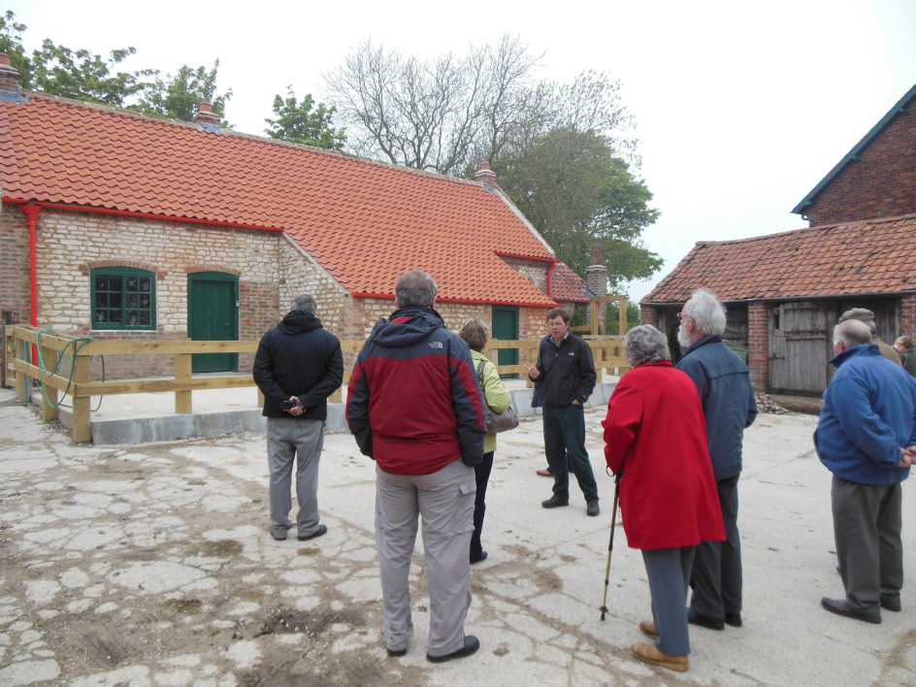
The interior has been made safe but has been mainly left so that the structure can be seen.
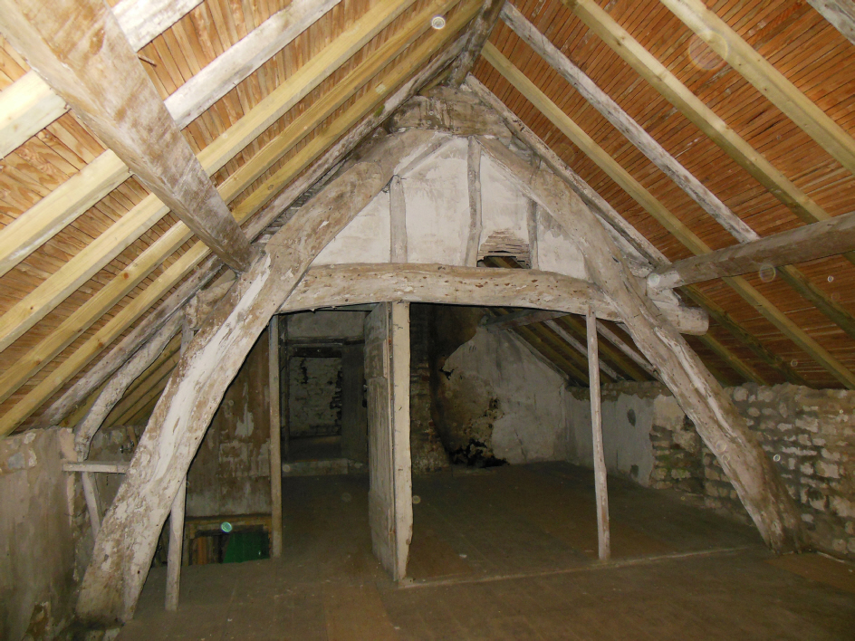
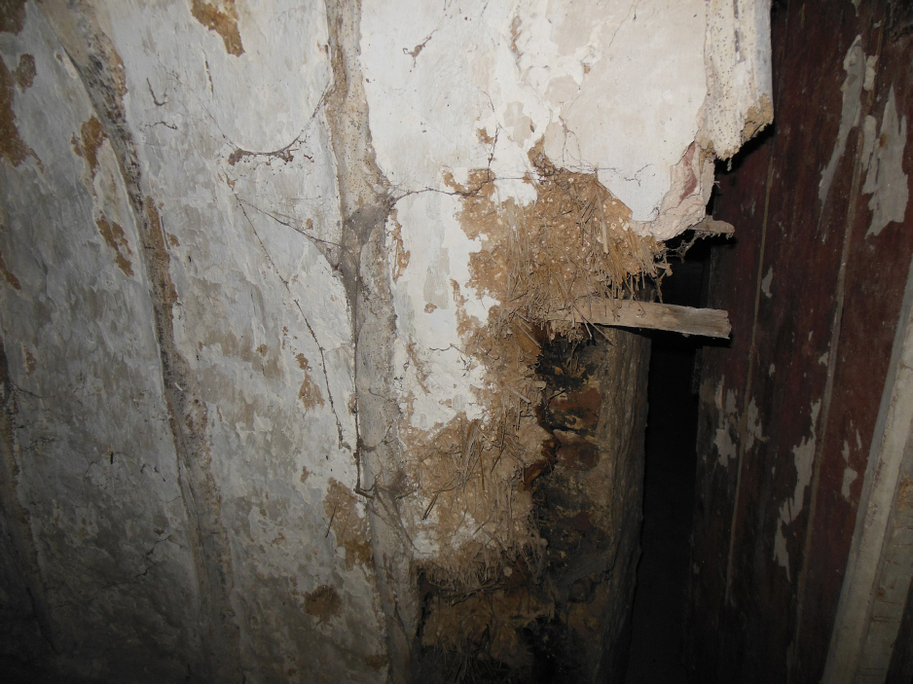
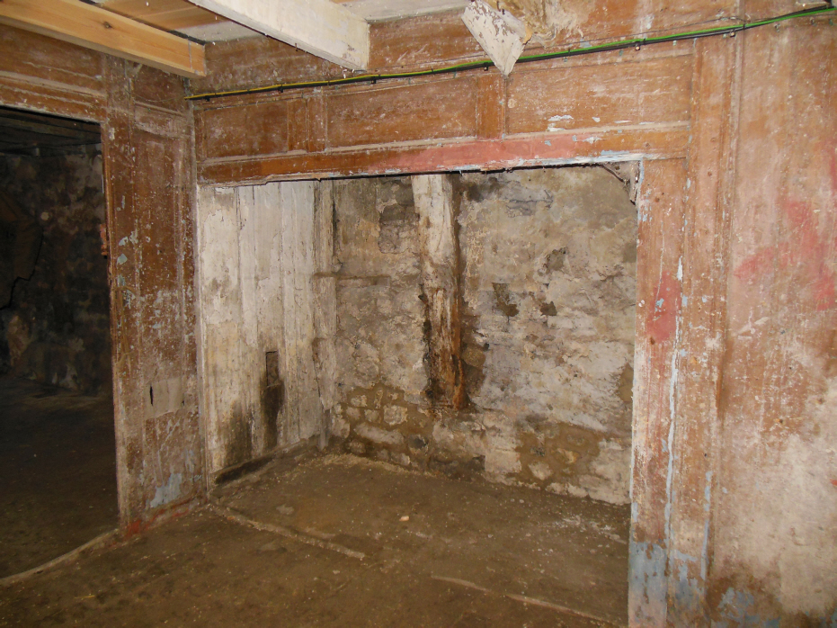
Space for an under-stairs bed.

Buildings in the yard are still to be restored, but they contain an eclectic mix of objects.
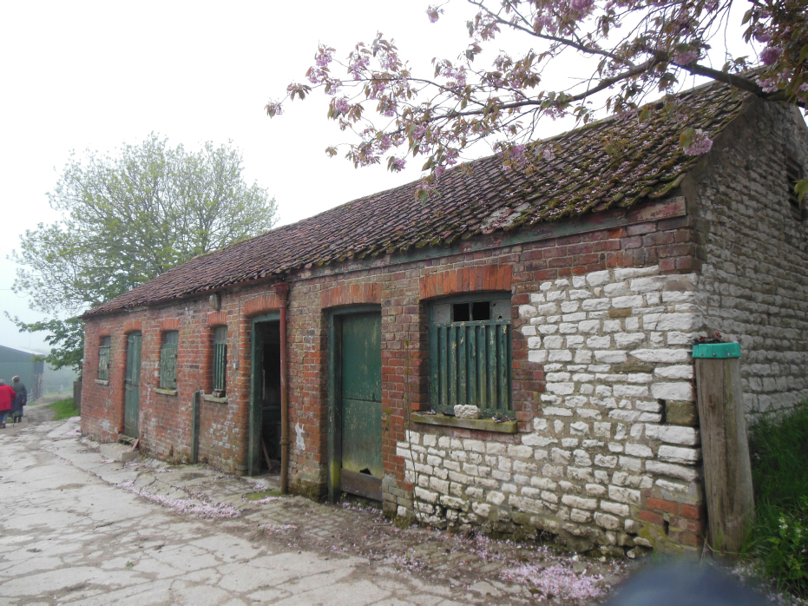
Pauline Foster demonstrates how this device was used to hold a gate back.
